Assignment 2.3
AI Assisted Coding
Name: Sunny Kolluri
HTNO: 2303A52444
Task 1:
Prompt: #Generate a Python class named Book for a simple library management system.
The class should have attributes title and author.
Include a method summary that prints the book details.
Use clean, readable, beginner-friendly code.
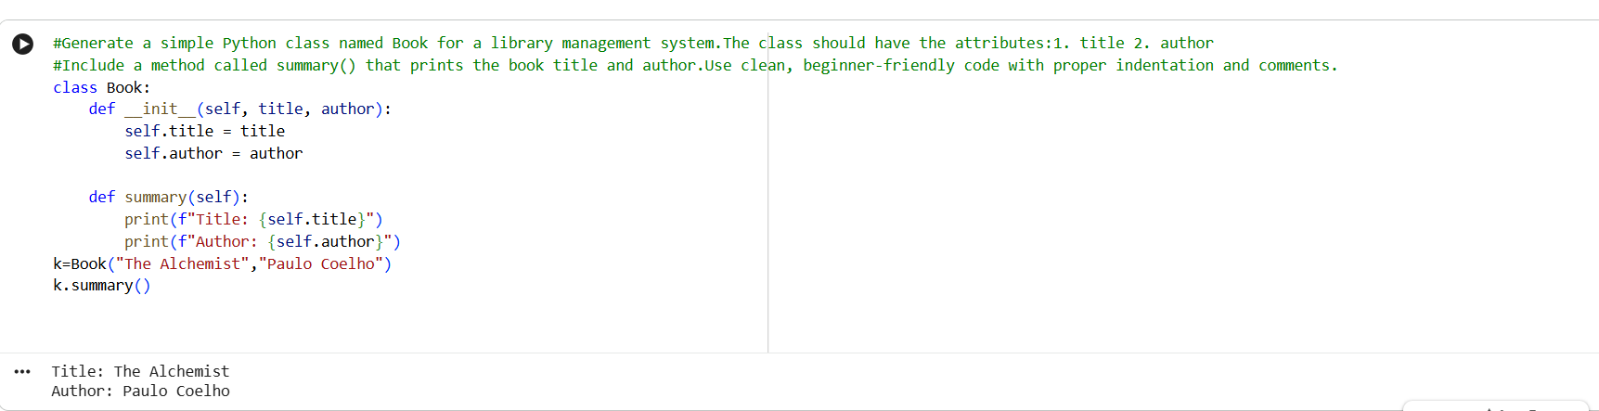

Observation:
The Python class Book was successfully implemented using object-oriented
programming concepts. The class contains appropriate attributes for storing
the book title and author. The constructor correctly initializes
the object with given values.

The summary method effectively displays the book details in a readable
format. The code is simple, well-structured, and easy to understand for
beginners. Proper indentation and meaningful variable names improve code
readability and maintainability.
Task 2:
Prompt: # Write a Python program to sort a list of dictionaries by age.
Each dictionary should contain name and age.
Explain the code clearly.
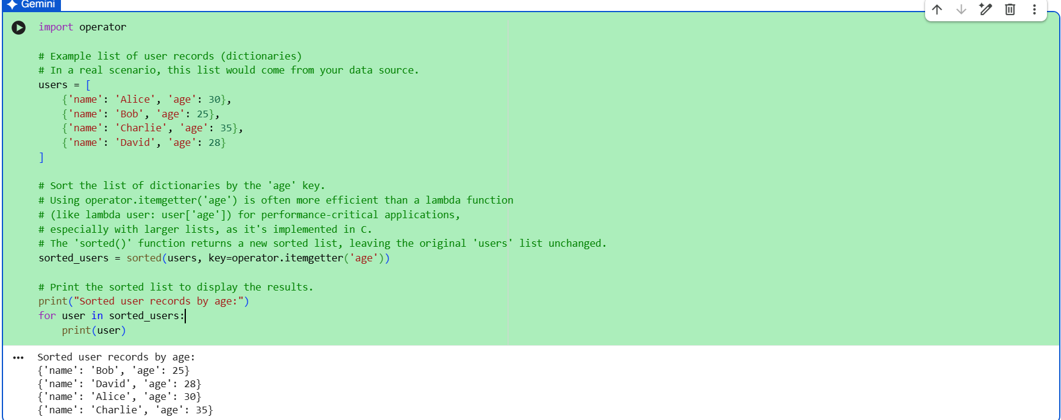

Observation:
The program successfully sorts a list of user records stored as dictionaries
based on the 'age' key. The use of improves code
readability and provides better performance compared to a lambda function.

The sorted () function efficiently returns a new sorted list without modifying
the original data. The output is displayed clearly, showing users arranged in
ascending order of age. Overall, the code is well-structured, efficient, and
suitable for handling larger datasets.
Task 3:
Prompt: #Create a basic calculator in Python using functions.
Include addition, subtraction, multiplication, and division.
Explain how the program works step by step.
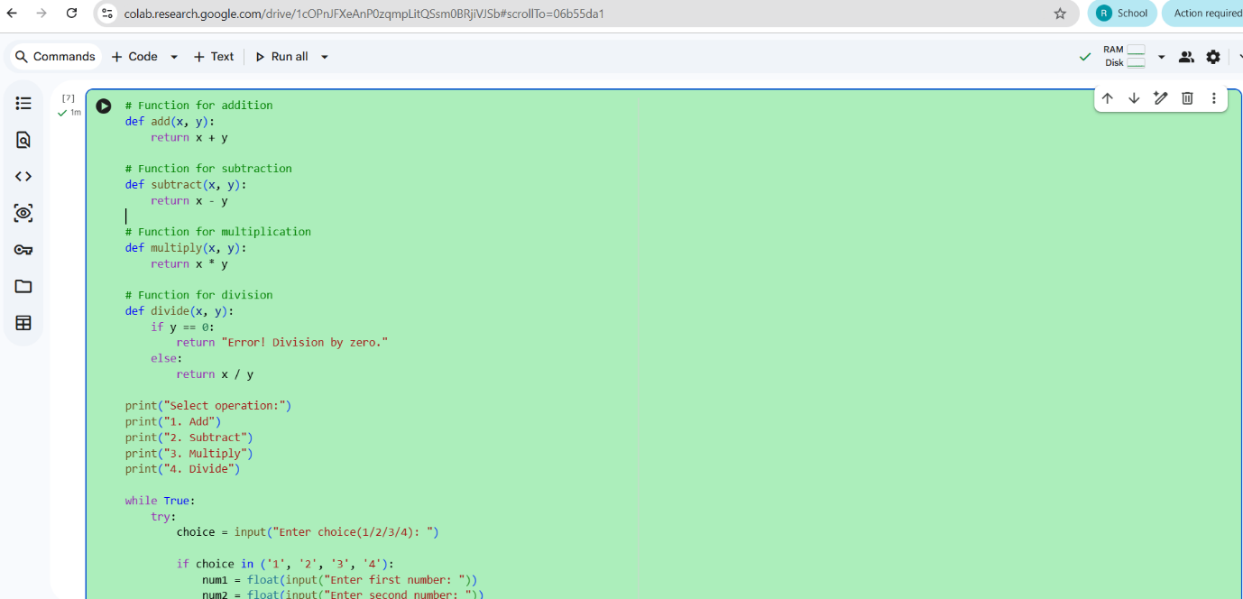
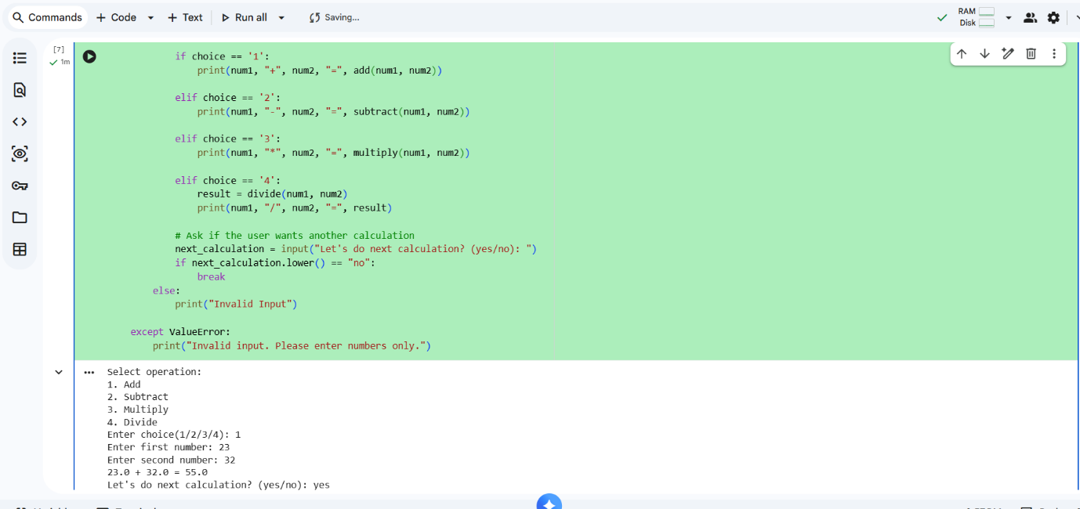

Observation:
The program successfully implements a basic calculator using Python functions.
Each arithmetic operation such as addition, subtraction, multiplication, and
division is defined as a separate function, which improves modularity and code
reuse.

The program uses a menu-driven approach and accepts user input dynamically.
Error handling is implemented using try-except blocks to manage invalid numeric
inputs, and division by zero is handled gracefully.

The while loop allows multiple calculations without restarting the program.
Overall, the code is well-structured, user-friendly, and demonstrates effective
use of functions and control flow in Python.
Task 4:
Prompt:
#Write a Python program to check whether a number is an Armstrong number.
Explain the logic.
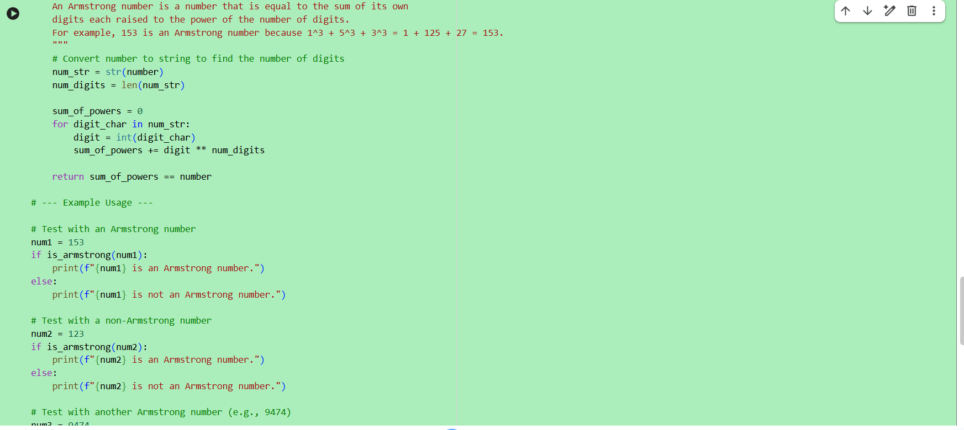
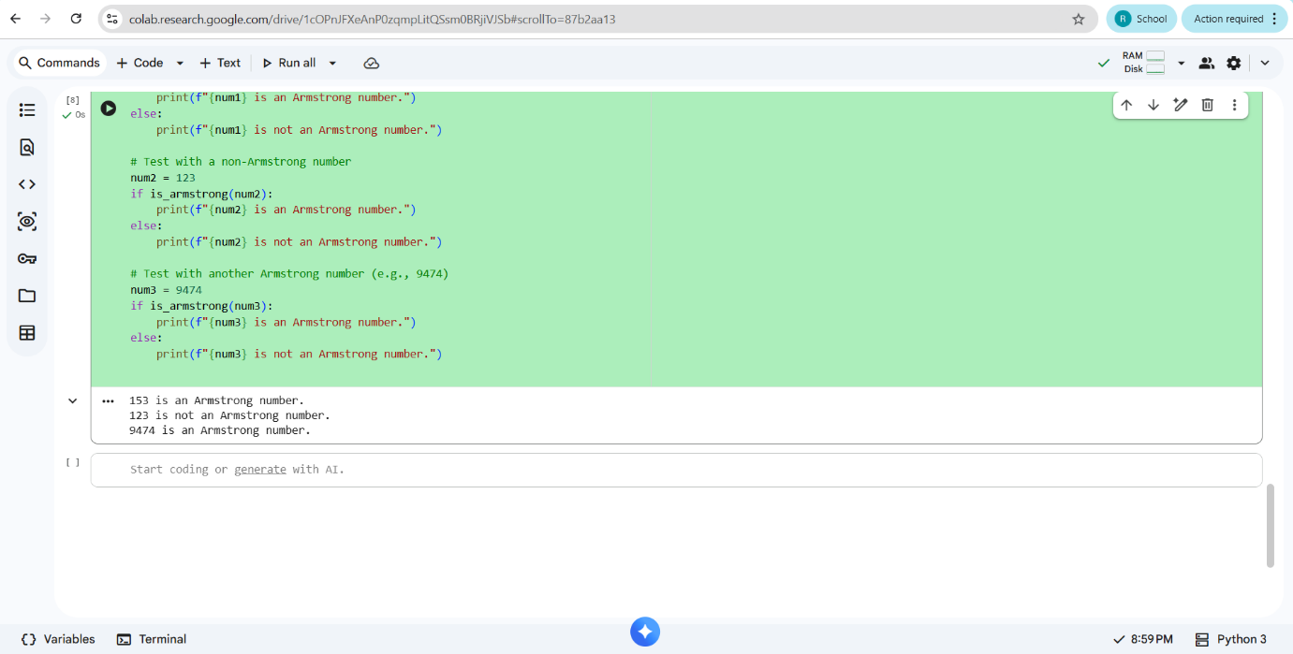
Observation:
The program correctly checks whether a given number is an Armstrong number.
It converts the number into a string to determine the number of digits,
which simplifies the calculation process.

Each digit is raised to the power of the total number of digits and summed
efficiently using a loop. The function returns a Boolean value, making the
code reusable and easy to test with multiple inputs.

Clear documentation and comments improve code readability and understanding.
The program produces accurate results for both Armstrong and non-Armstrong
numbers, demonstrating correct logic and efficient implementation.

